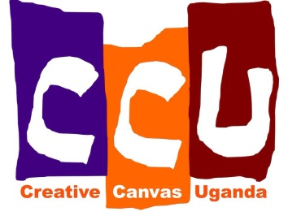
Creative Canvas Uganda
September/October Newsletter
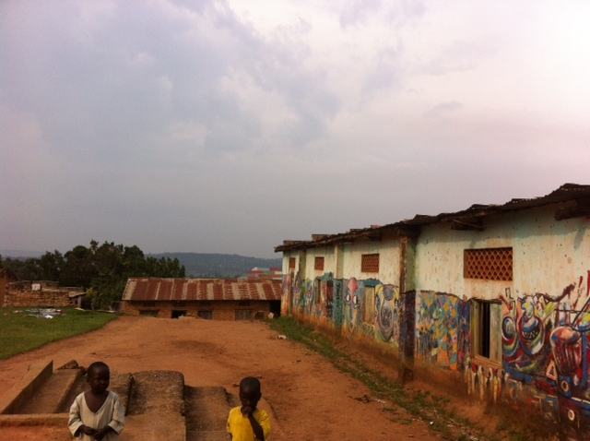
So here we are in Uganda, and the project is starting to gather momentum. On October 8th, we signed the lease on the plot of land and buildings we are renting for the community centre. Renovations can now begin! The first task is to renovate the main building (seen on the right of the picture), including a new roof (a mammoth task..), re-doing some brickwork, plastering, painting and improving the windows. We will also spruce up the smaller rooms on the site (the buildings seen at the far end of the main building), which will be used as classrooms, a kitchen and a library. Once the roof is complete, we will be able to start collecting water into the water tank. This will be vital for supporting the project, especially the animals and farming projects. Renovations begin on Monday, so watch this space…
As part of our research into local farming techniques and animal husbandry, Carson, Neil and I went to visit a small-scale sustainable farming project on the outskirts of Masaka. We had a two-hour tour and couldn’t believe how much we learnt. St Jude’s Family Project was a huge inspiration, and has given us so many ideas of projects to use with the children in Ndegeya. St Jude’s ethos is to show the community that small scale farming is possible on even the smallest plot of land. Learn more about them here: http://stjudefamilyproject.webs.com/
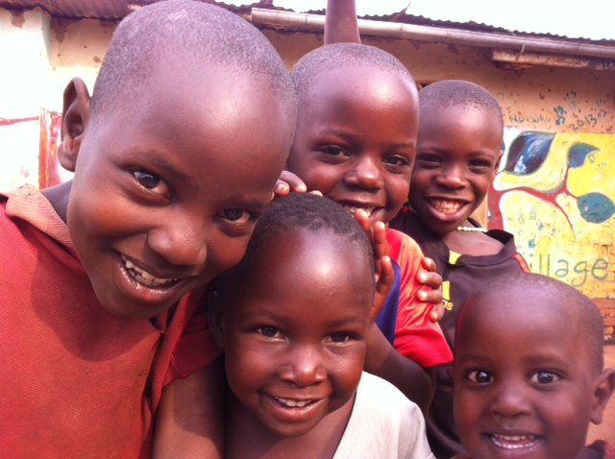
We are excited to be here on the ground and can’t wait to see Carson’s vision realized. Keep up to date with day to day changes on our Facebook page. We are working with a minimal budget, and using local labour and materials for the whole project. Please share us with your family and friends and help us to spread the word.
With huge thanks from us, and Ndegeya’s beautiful kids:

Until next time,
the CCU team.
www.creativecanvasuganda.org

