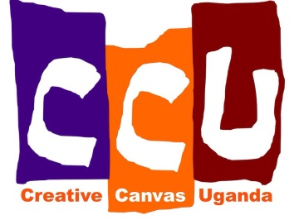
Creative Canvas Uganda
October/November Newsletter
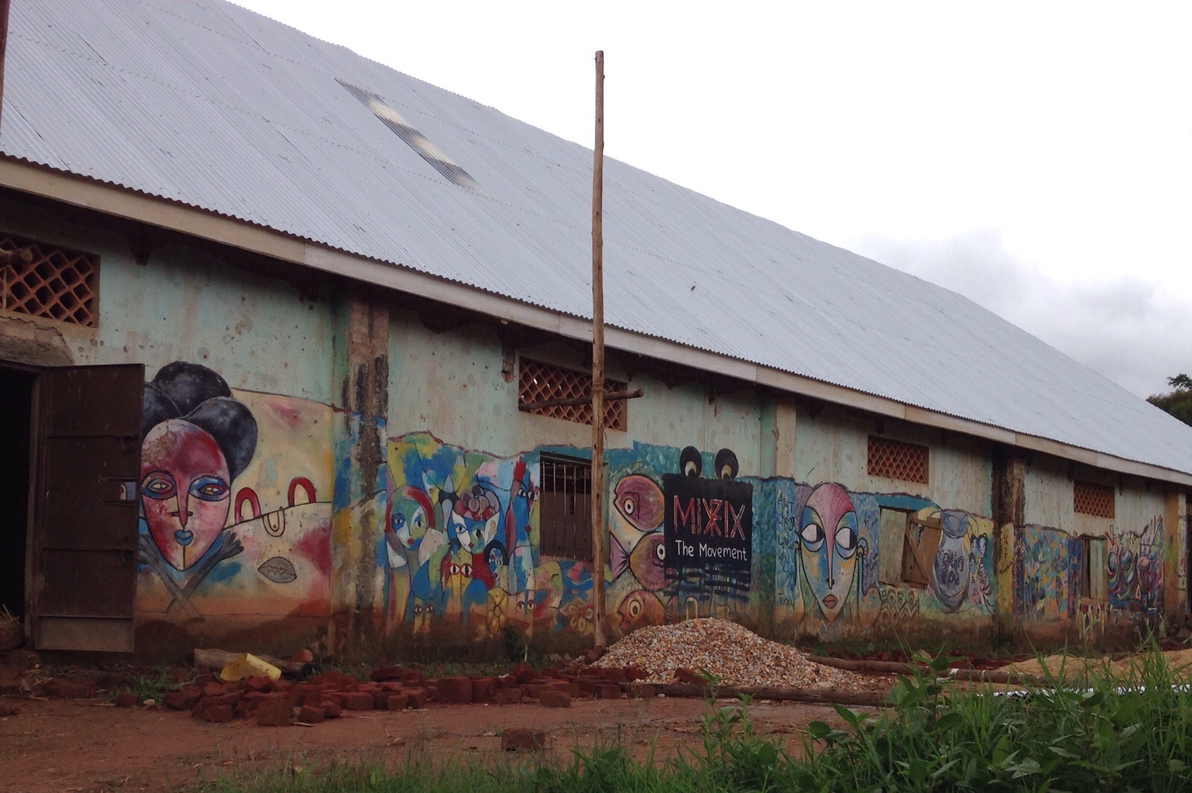
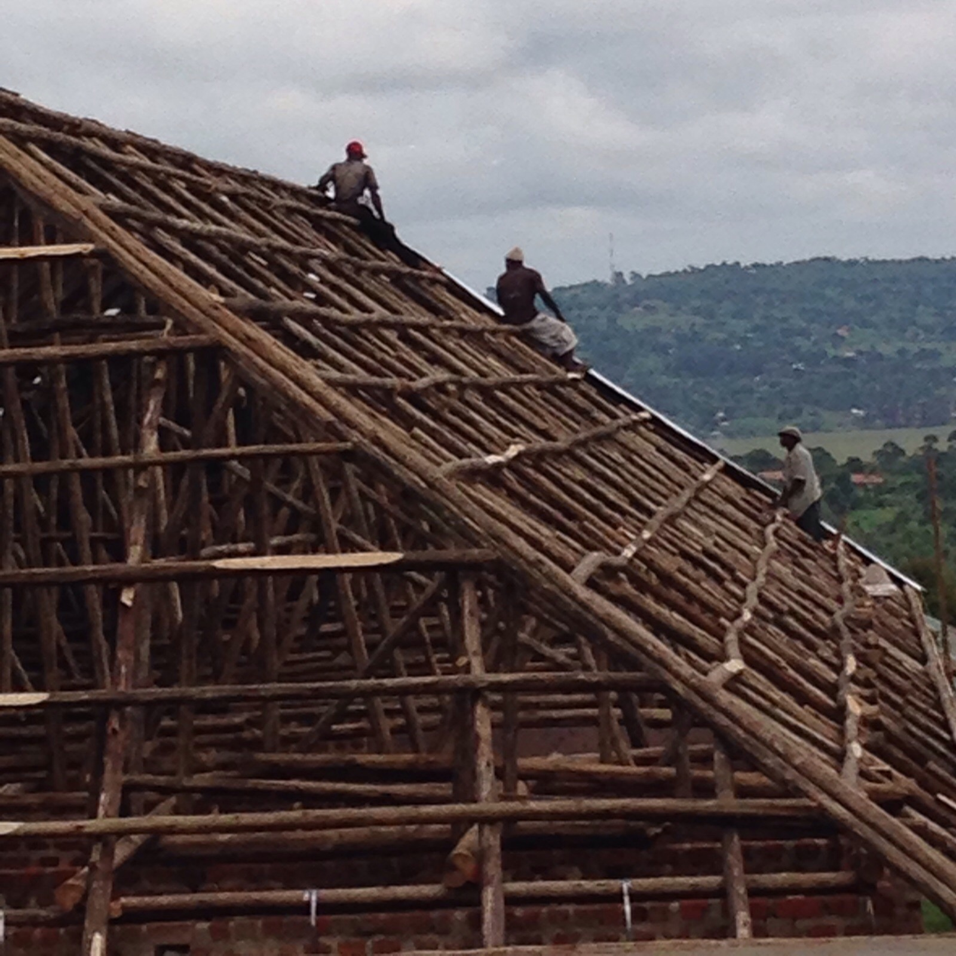
Welcome all to the latest newsletter. This month has had a main focus on roofing and painting. After some unique Ugandan building techniques, the roof for the community centre has officially been finished! It has a guttering system that means every time it rains (and considering it is currently the rainy season, this is pretty often), the water that runs off the roof is collected in the water tank and can be used at the centre. Thus there is a self-sustainable water source – something that everyone here is beyond excited about.

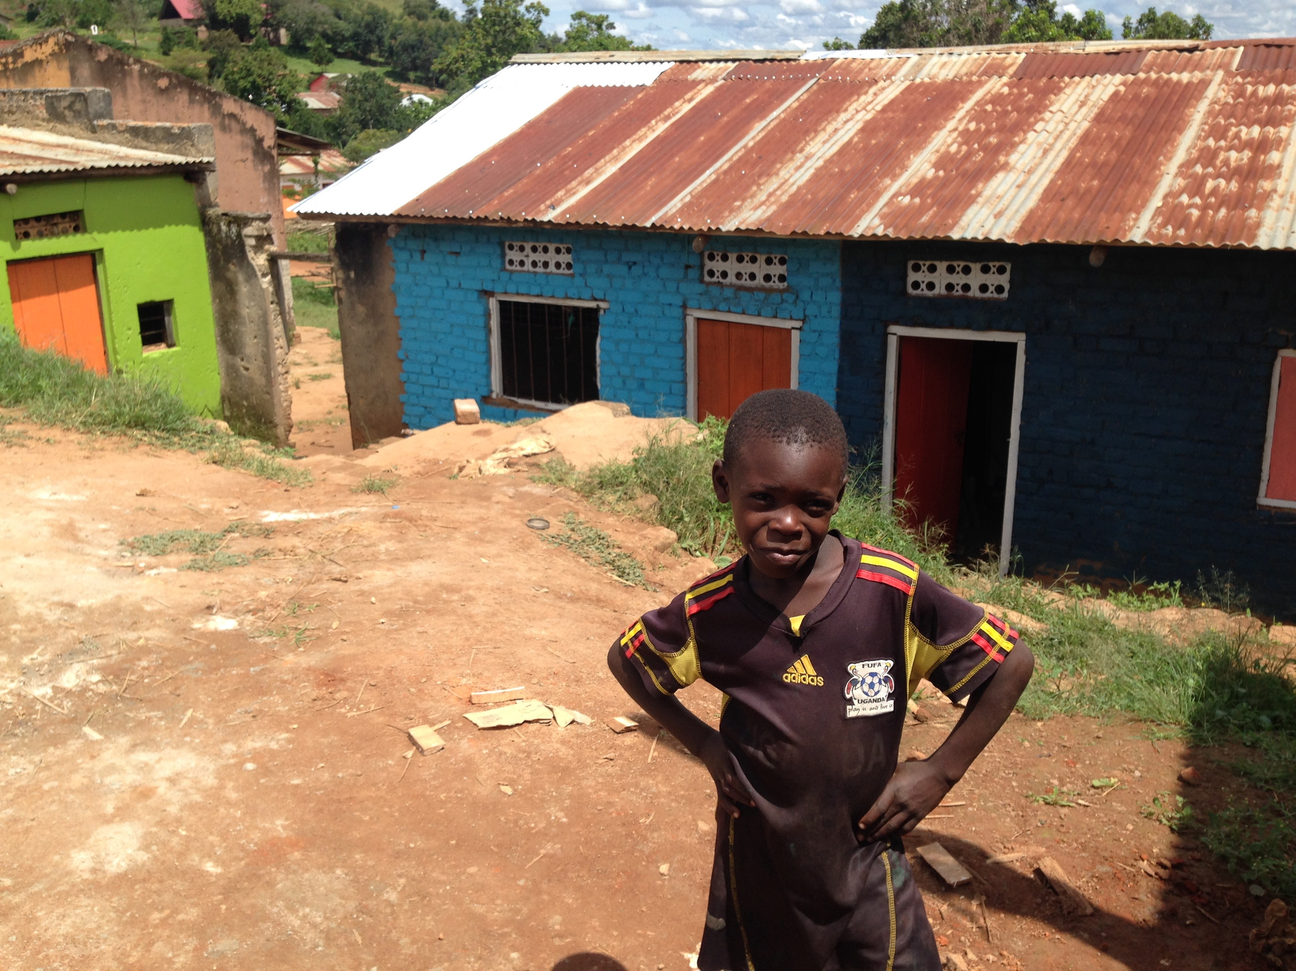
There has also been a mass paint-job taking place. The buildings that will be used for classrooms, the library and the kitchen have all been given a new lease of life thanks to the expertly chosen colour pallet that was used. The latrines are also looking fantastic after a good lick of paint. Still to paint is the chicken coop and the inside of the community centre, so look out for pictures of those finished products!
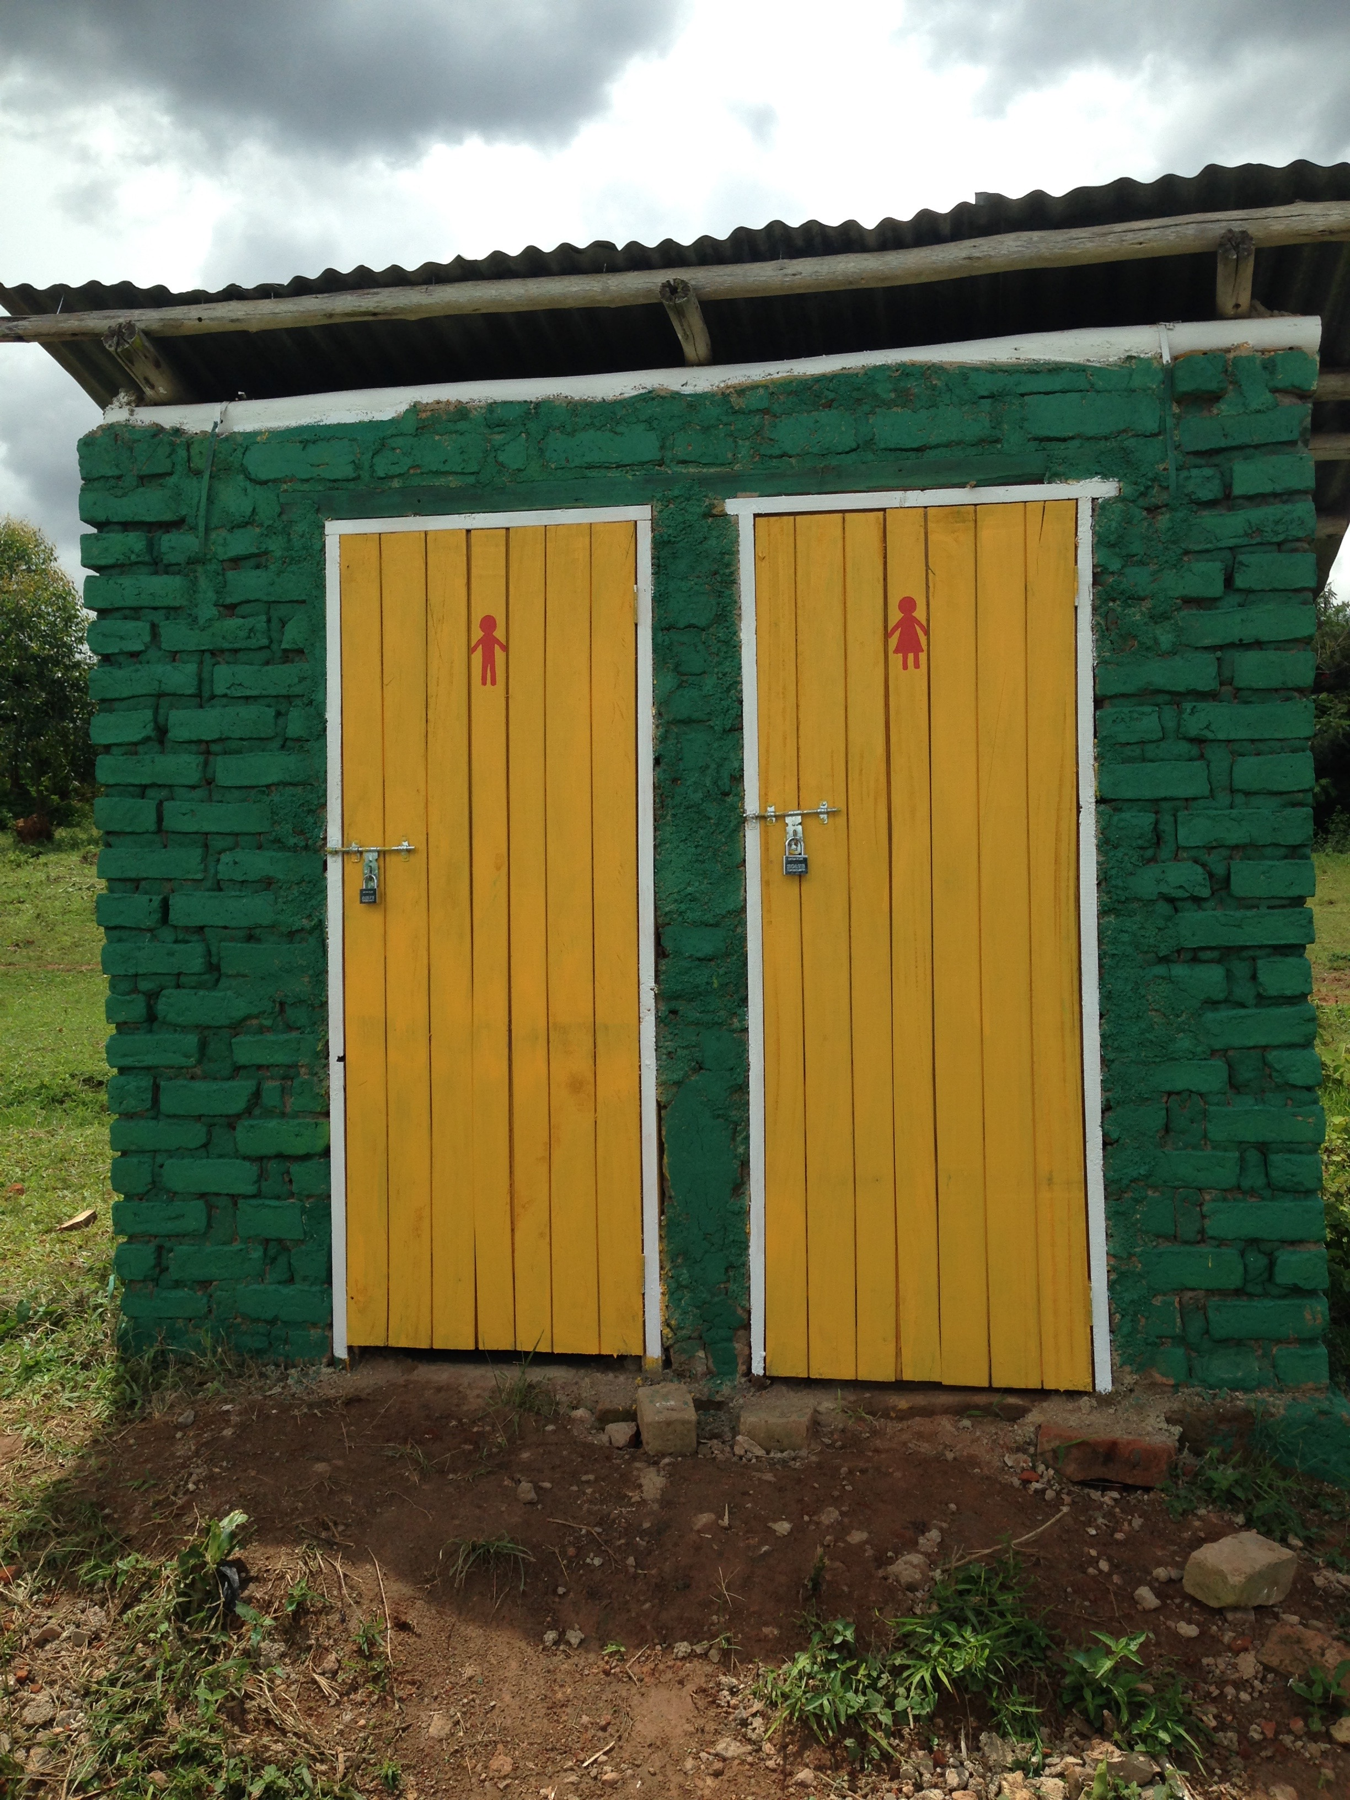

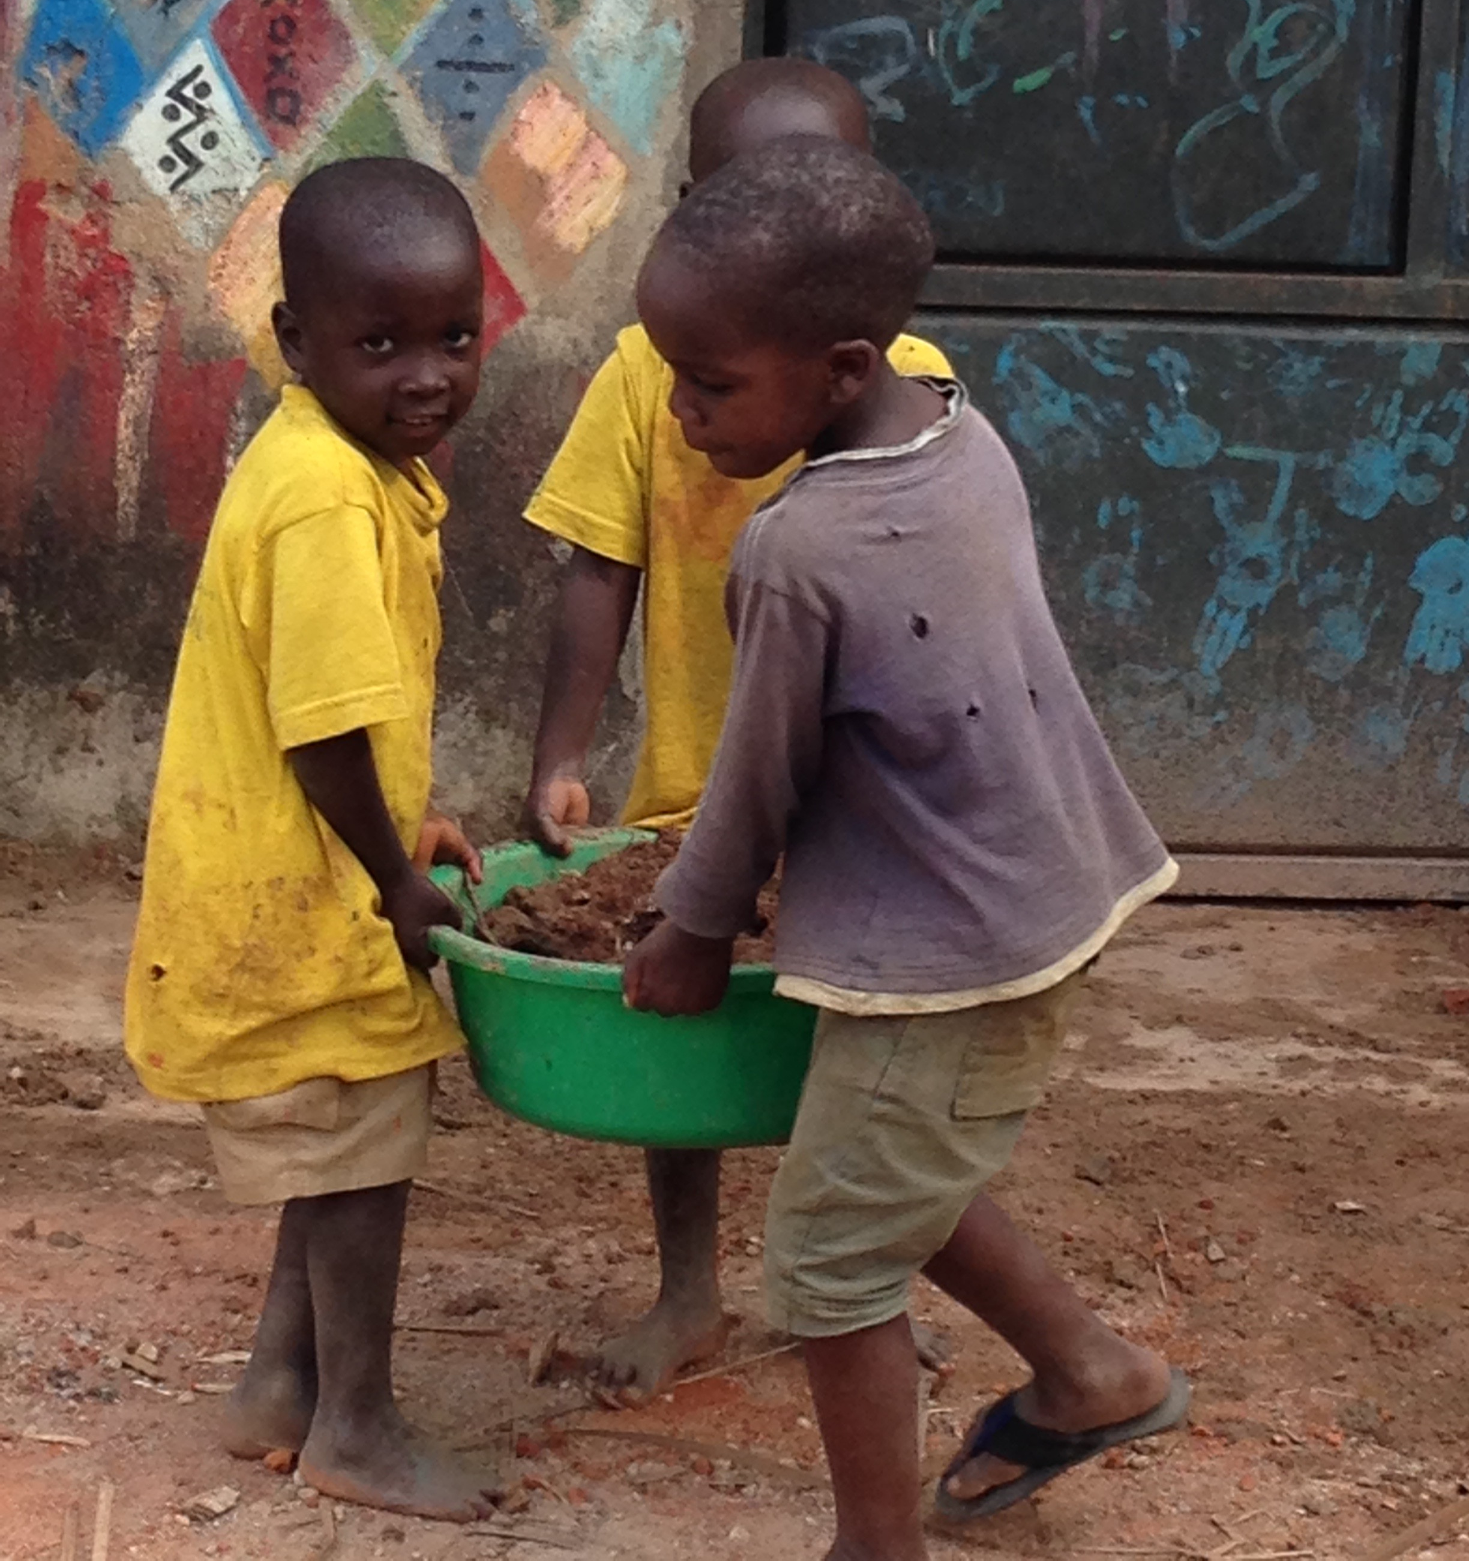
After a chance encounter with a villager at the local shop, we questioned Carson more about the original uses for this building, and discovered a tragic history. The main hub and its outbuildings were, for many years, the only discotheque in the Masaka area. Due to the activities associated with discotheques, the centre sadly ended up being a hub for the spread of HIV, earning the name for itself as the place where much of the HIV in the Masaka area was contracted. For this reason, the centre was closed in 2009 and has sat empty ever since.
This sad story was hard to hear, but we definitely feel a bittersweet silver lining that, from now on, this centre will be used to support the kids living with the aftermath of the HIV decimation; it has inspired us even more to ensure that the future of the centre is only positive.

Coming this month…
Plans for the coming weeks include:
- Fencing the area for security
- Building a keyhole garden
- Planting seeds and building a compost heap
- Buying chickens for our freshly renovated coop

The project is coming along really well and we are all thrilled with the progress, but there is still a long way to go and we have been quite constrained by some unexpected financial stresses, so any help goes a long way here!
Thank you all once again so much for your support, and please continue to share our updates with anyone who might be interested.
Until next time,
the CCU team.
www.creativecanvasuganda.org

