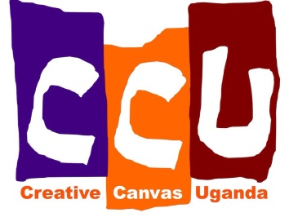
Creative Canvas Uganda
November/December Newsletter
Hi everyone and welcome to the final newsletter of 2015! This month has seen the project really starting to come together, and there is a real buzz in the community about it.
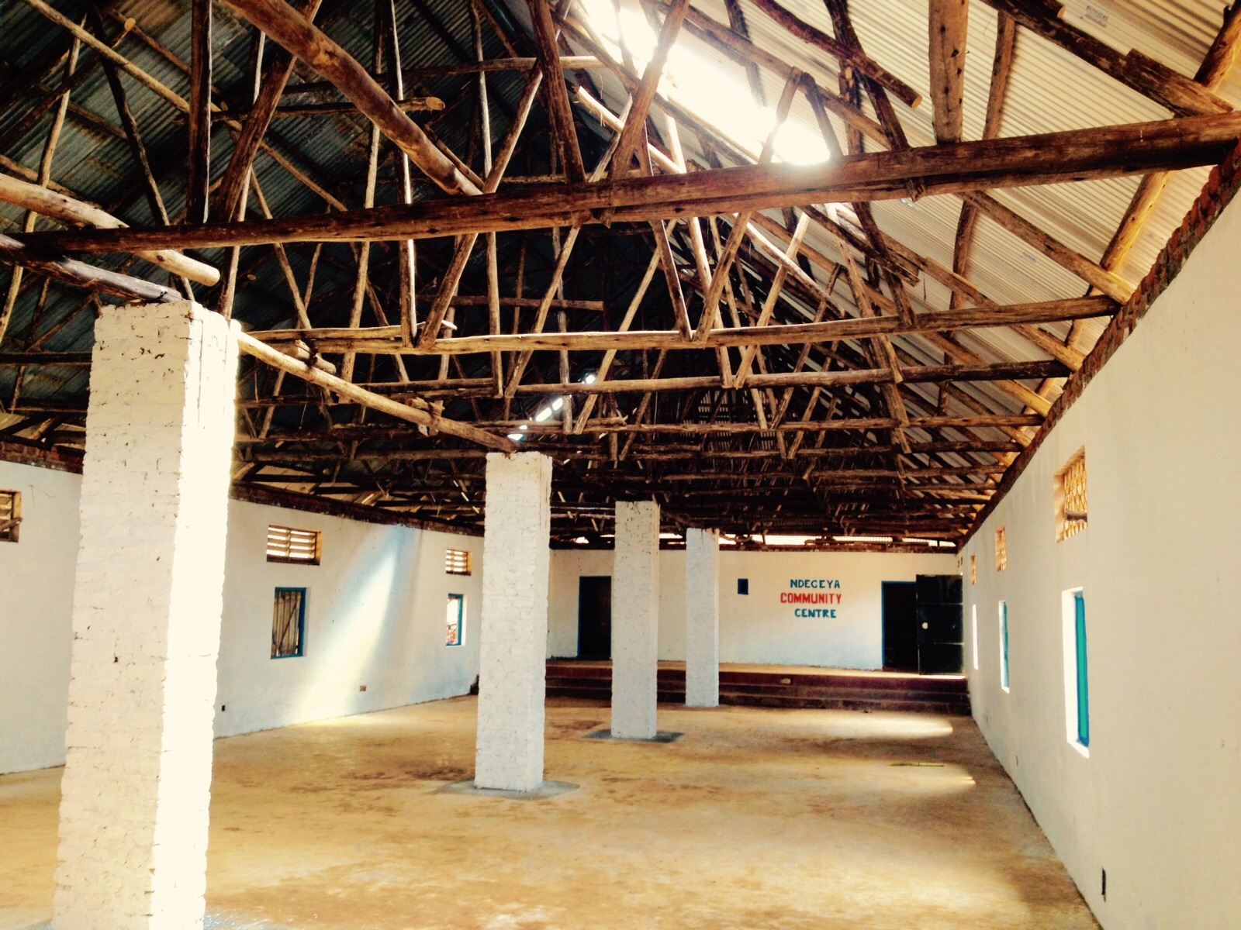
We have finished the paint job in the main hall, and it is now such a contrast to the sad state it was in when we first arrived. I’ve included before and after shots for a real sense of how much it’s changed! The whole compound is now also fenced, thanks to our kind donors.
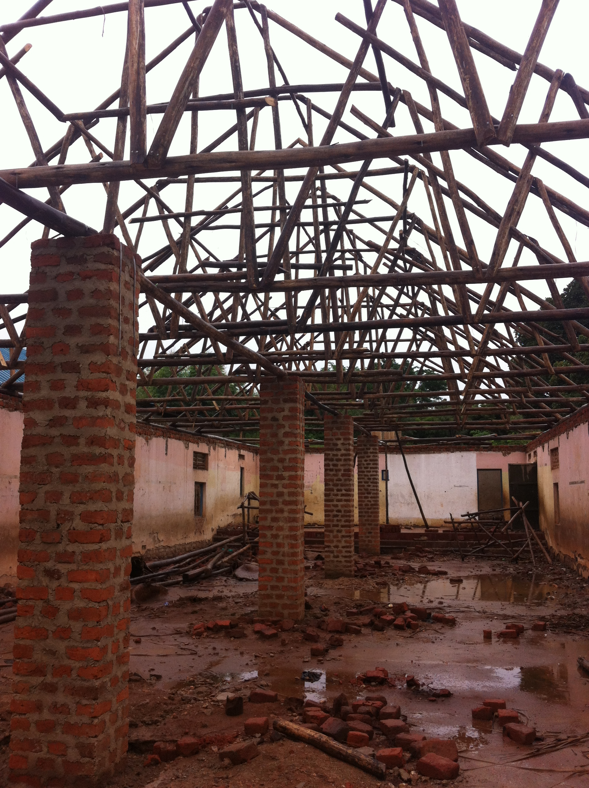

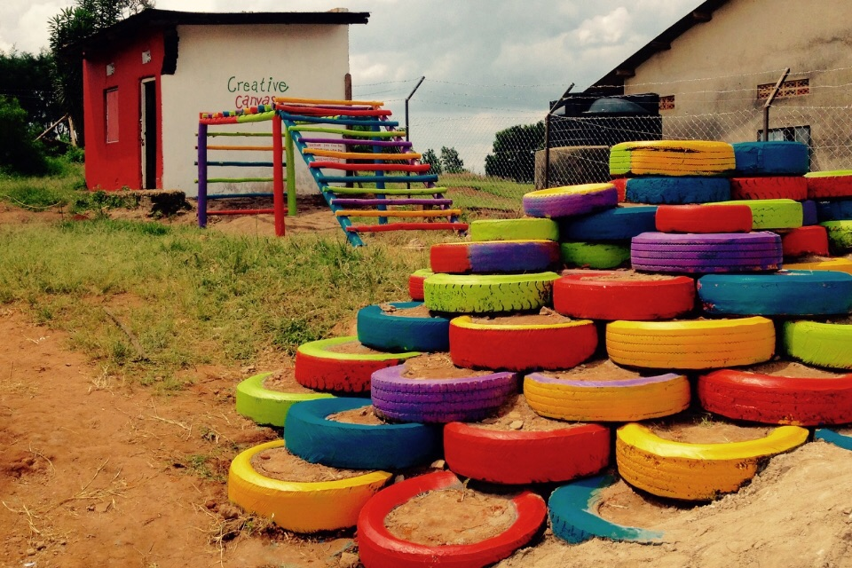
Thanks to the help of a local mechanic friend (thank you, David!), we acquired 60 old truck tyres, and constructed a tyre playground.
Our resident carpenter, Mutebi, then casually knocked up a wonderful climbing frame in an afternoon or two…!
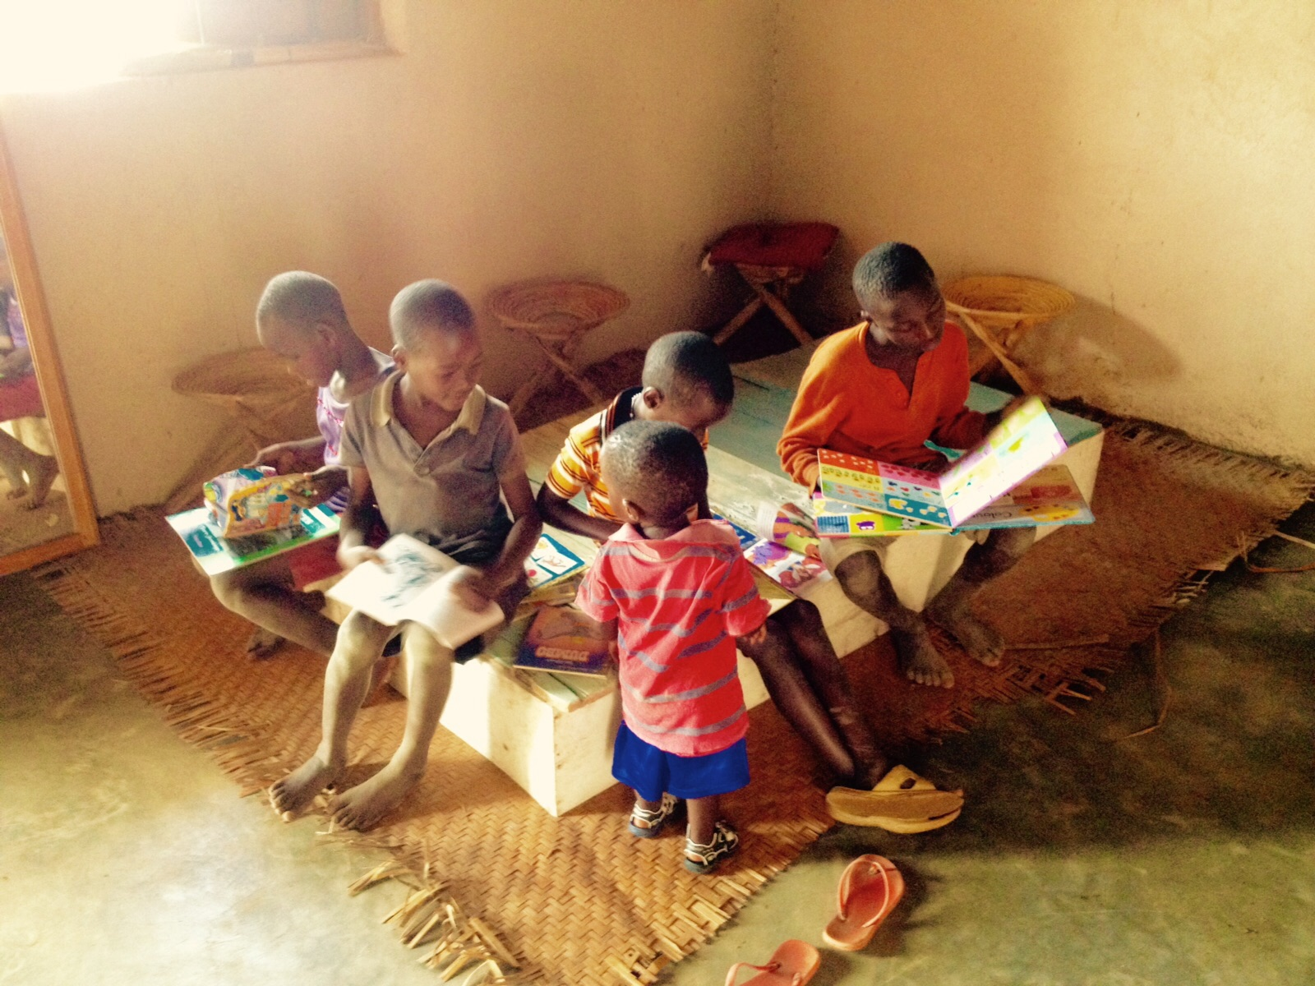
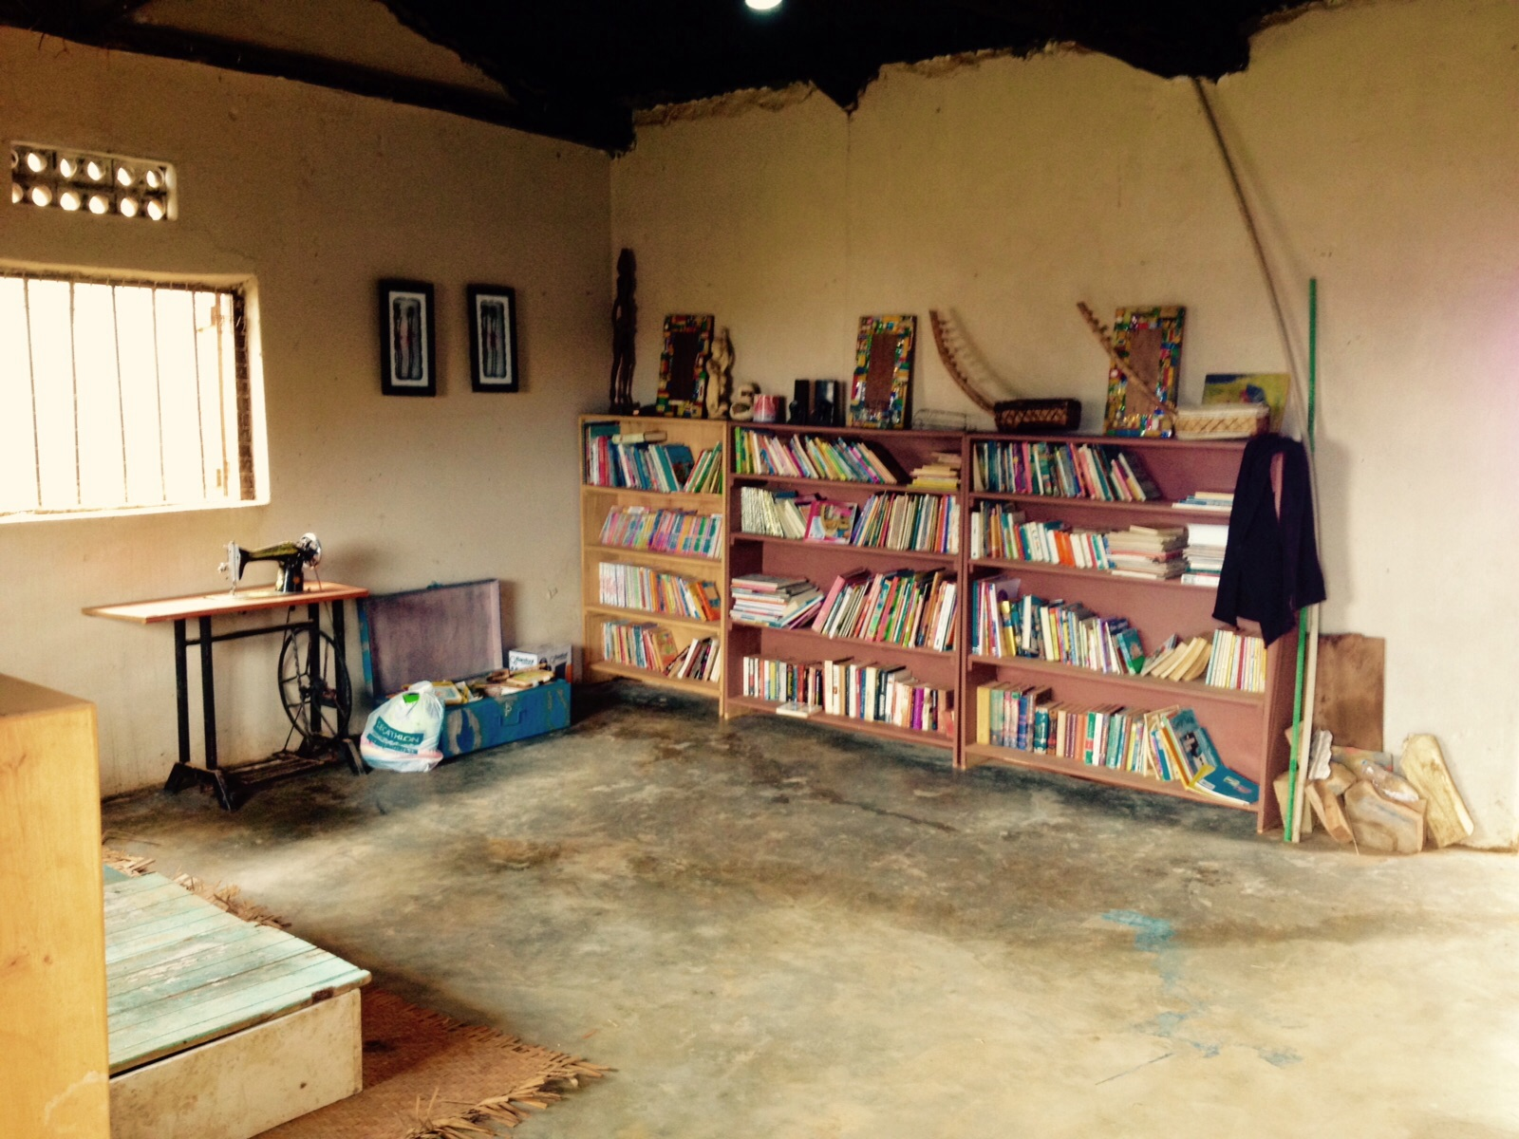
There has been some roof work on the front buildings, so they are now all secure and weatherproof and have been given a little facelift too! We have a classroom and library, complete with chalkboards made out of Carson’s homemade blackboard paint (sweet potato leaves and crushed charcoal). These rooms now have solar power, which is a first in the village. We intend to open up the classroom at night for students to come and do their homework in the light.
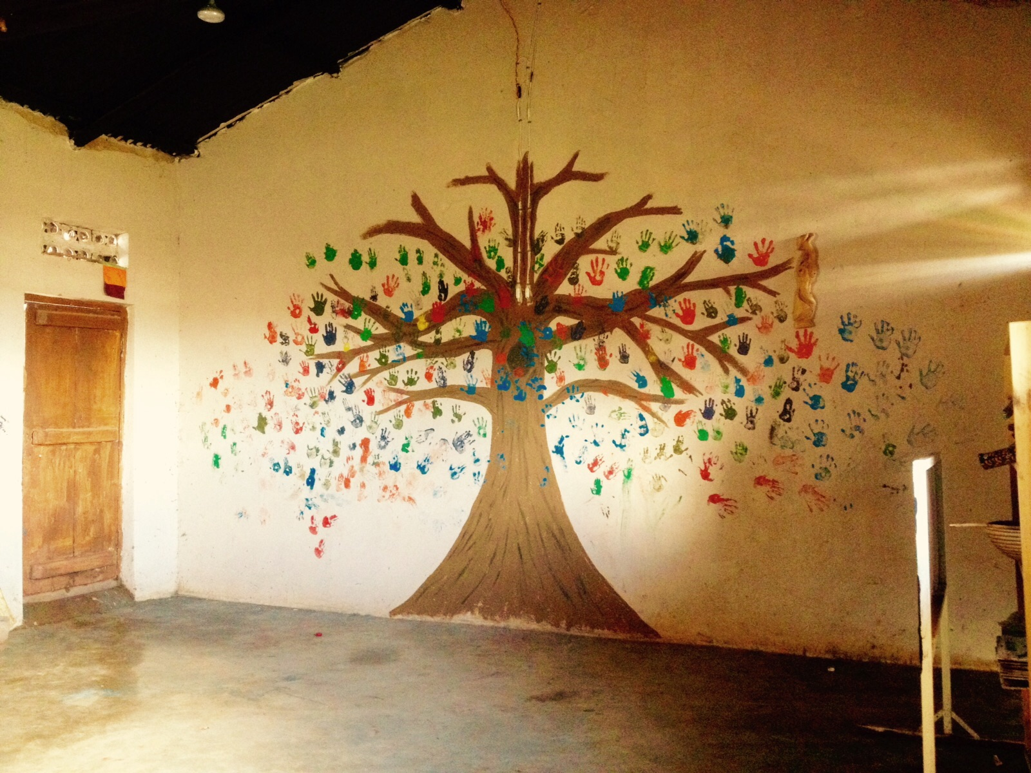
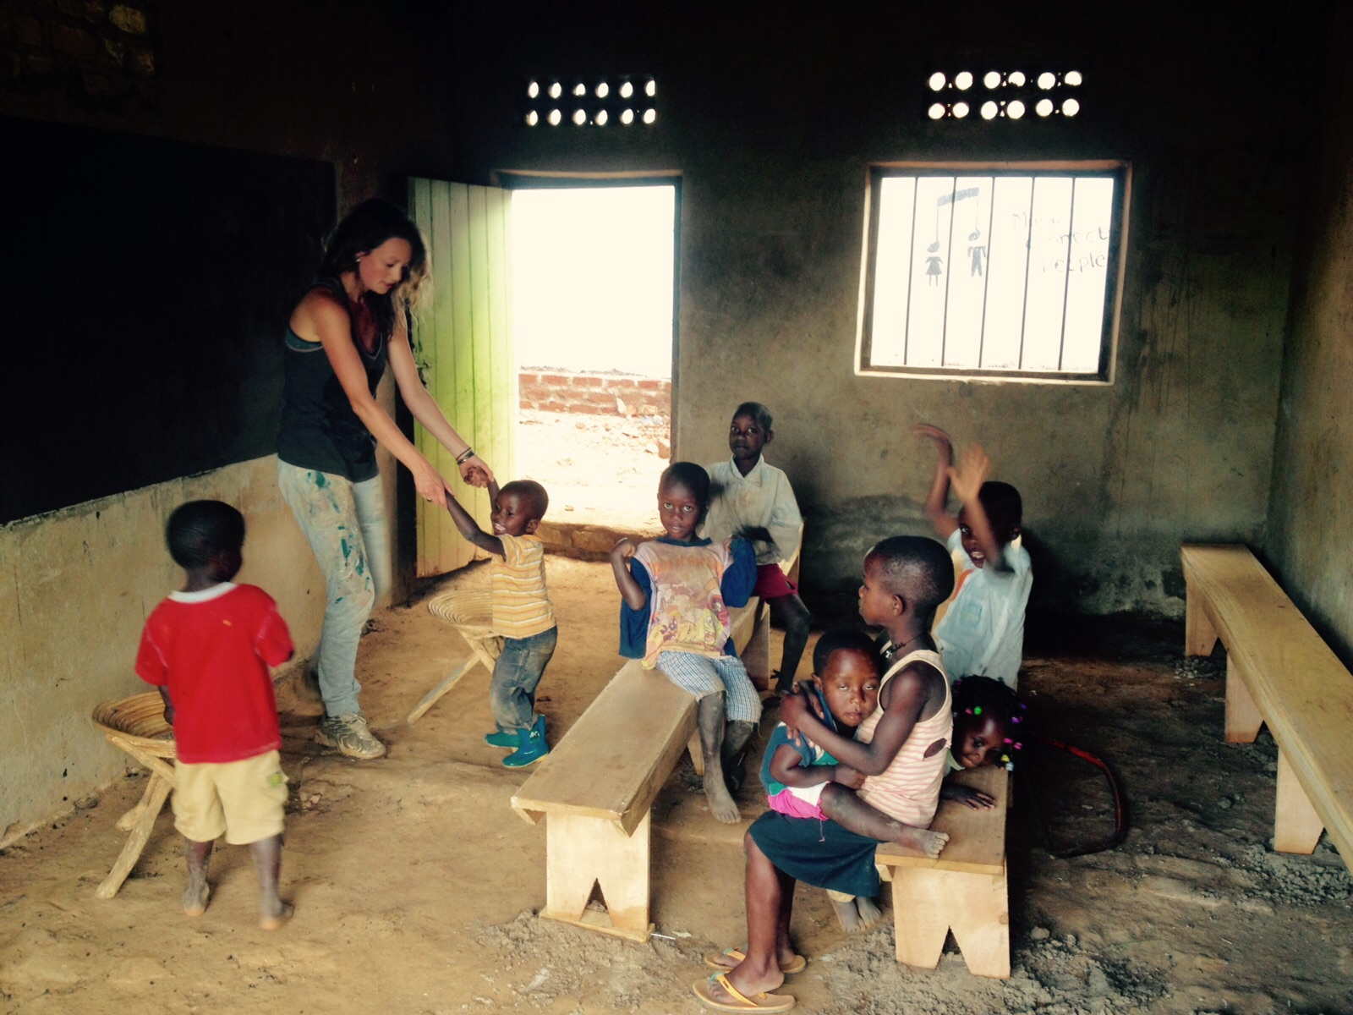

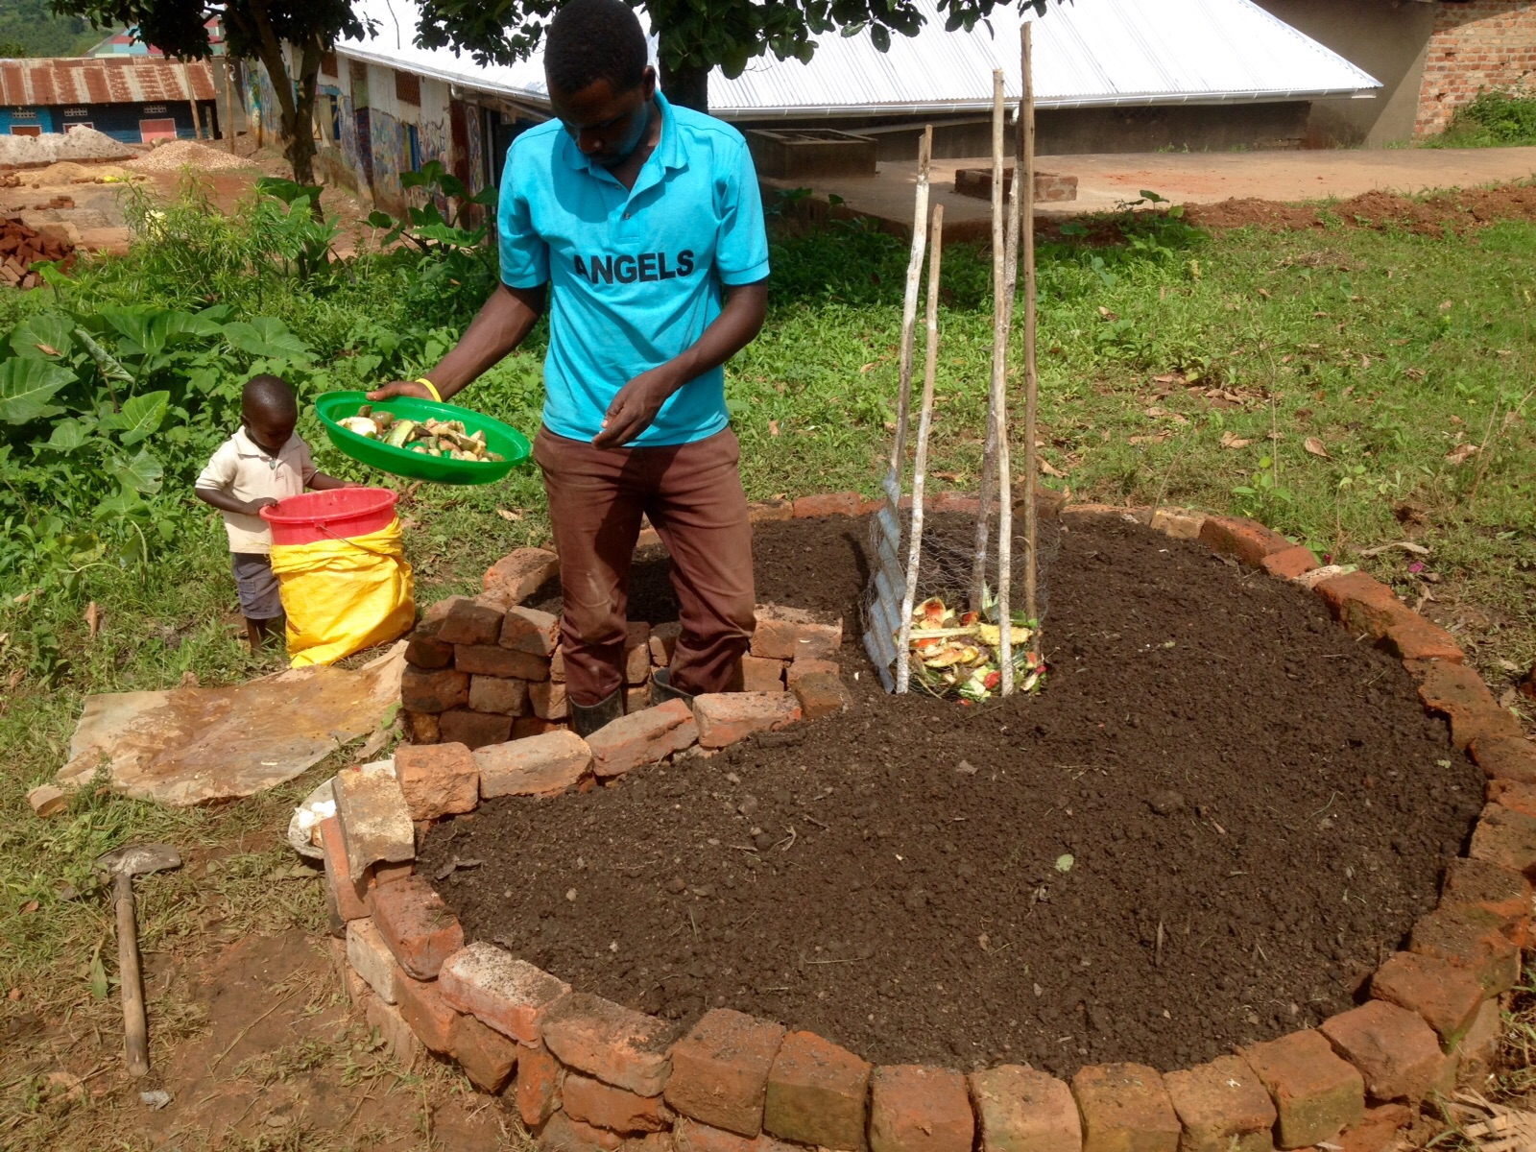
The garden is also looking great, thanks to the new additions of four keyhole gardens, a roof garden, and a series of bottle gardens. The children have helped us to plant seeds and are enthusiastically checking their progress. Lots of vegetables, fruits and herbs should soon be appearing…

Last Saturday, we had 28 volunteers come down to the centre from Kampala. The day was completely manic, with around 60 children for activities and lunch in the morning, and then a group of around 40 members of the community in the afternoon for presentations from the volunteers on sustainable projects: water harvesting, solar power, and rabbit farming. However, it was a big success, with the kids, villagers and volunteers all enjoying themselves. 3 clay water filters were kindly donated by one group, so we will now be able to have safe drinking water filtered on site.
We have also had a US Peace Corps volunteer offer to take fitness classes at the centre for the next few years he is in Masaka. The first class was held last week and was a great success.
Coming this month…
- Preparing a kitchen, including building a bio-gas stove
- Buying chickens for our freshly renovated coop
- Planning the program for the years to come
- Planning a volunteer program
- Sourcing teachers and members of the community who wish to be involved
- Setting up links with the health centre next door, to work with them for HIV testing, awareness workshops, and more.

Overall, the project is shaping up really well. There is still plenty of work to be done, but at this festive time, all we want to say is a huge thank you for all your continued support and interest. None of this would have been possible without the support we have received from family and friends, both old and new. Thank you and, from all of us in Ndegeya, a very Happy Christmas to you all!
